Analysing Neighbourhoods of

Manchester For Starting A New Restaurant.

Saloni Shaswat

IBM Applied Data Science

23.01.2021

# **Introduction**

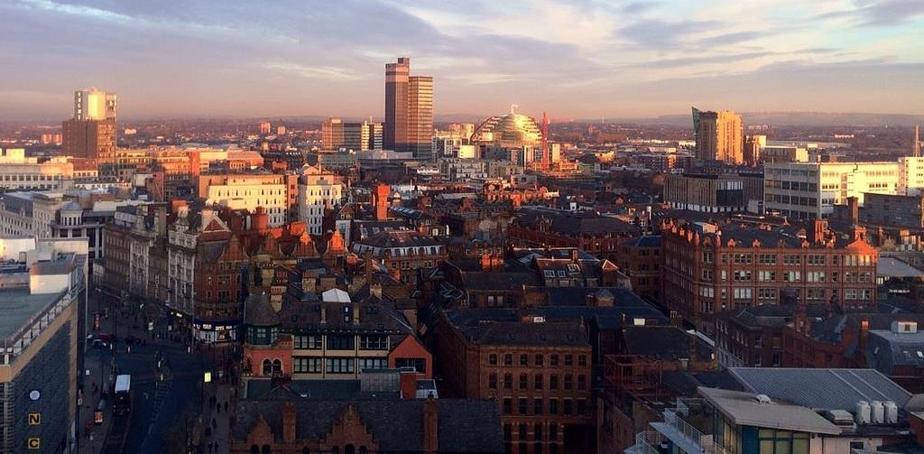

* Manchester: One of the biggest cities in UK
* United Kingdom's second-most populous urban area, with a population of 2.9 million
* The population comprises of people of various ethnicities from all over the world

**Business Problem**

* Start a restaurant
* Neighbourhood that is most likely to give a good business

# Data

* Neighbourhoods of Manchester
  + Neighbourhoods of Manchester wikipedia page through data scraping.
* Geographical coordinates of the neighbourhoods
  + Using GeoPy library.
* Venue data from FourSquare
  + Using FourSquare API

Methodology

* Feature Extraction – One Hot Encoding

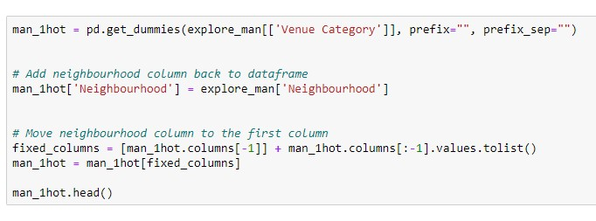

* Unsupervised Learning
  + K-Means Clustering

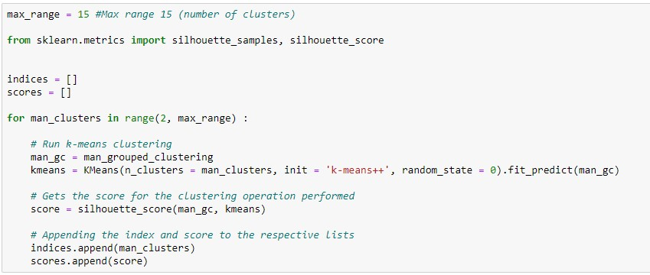

* Plotting
  + Folium

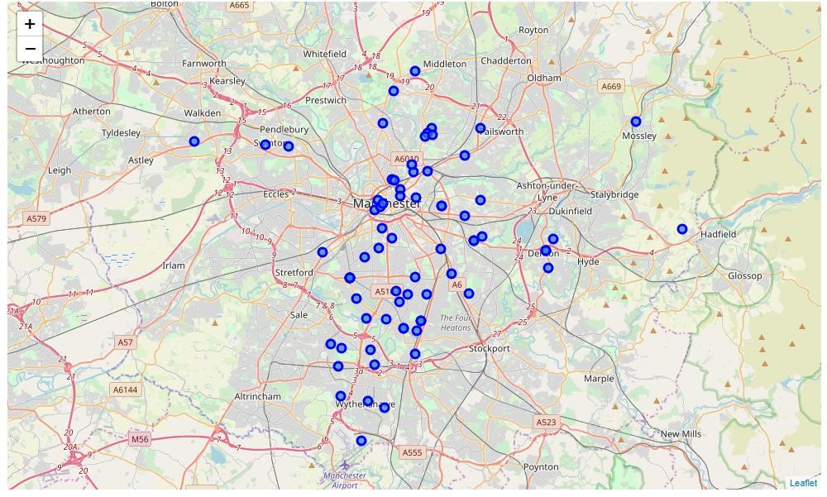

# Results

* Visualization of clusters

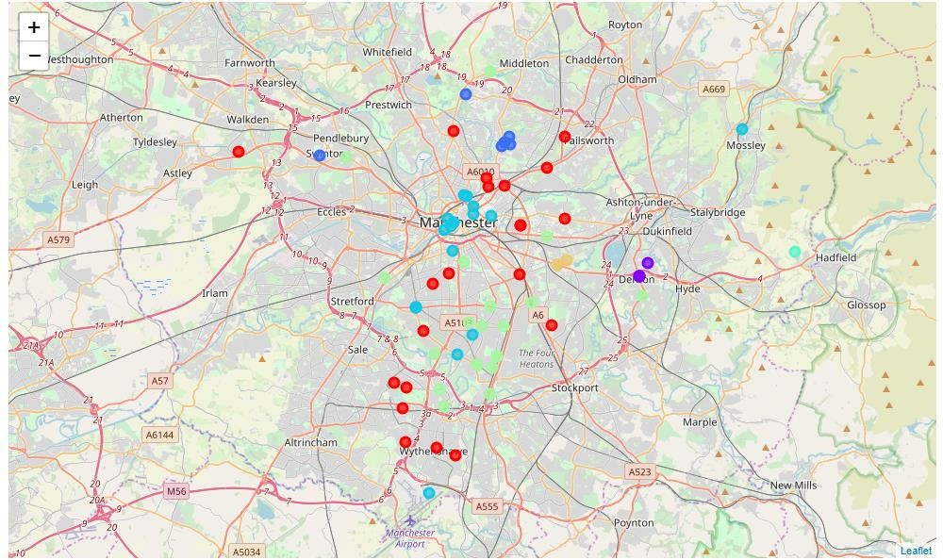

* After visualising the clusters, the individual clusters were studied and some important conclusions were derived. The neighbourhood that had the most number of restaurants was cluster number 4.

## Discussion

* Most suitable neighbourhoods for starting the restaurant business are present in the cluster number 4.
* Our K-Means model worked perfectly and successfully clustered similar neighbourhoods together.
* After studying all four clusters, it is recommended to the client that neighbourhoods such as Barlow Moor, Brookelands and Hyde Newton (Ward) that fall in cluster 4 look like good locations for starting their restaurant business.
* The client can go ahead and make a decision depending on other factors like availability and legal requirements that are out of scope of this project.

## Conclusion

* Data analysis and machine learning techniques used in this project can be very helpful in determining solutions of certain business problems.
* Python’s inbuilt libraries such as GeoPy, Folium and BeautifulSoup make it very easy and effective to analyse a geographical location.
* In this project we studied the neighbourhoods of Manchester city and came up with a recommendation of neighbourhoods where our client can start their restaurant business.